[EVENT TITLE]

[DATE]

Event Overview
Visit Date | 15, 16, 17 June 2026 | Venue | Senate House
Arrival Time | 09:30 | Staff Lead/s | Gaia Worley-Barstow
Departure Time | 15:00 | Contact Phone / Email | g.worley-barstow@greatermanchester.ac.uk

event logistics
Please find further information about your upcoming visit below. If you have any further questions, please contact event leads using the contact details above:

Arrival
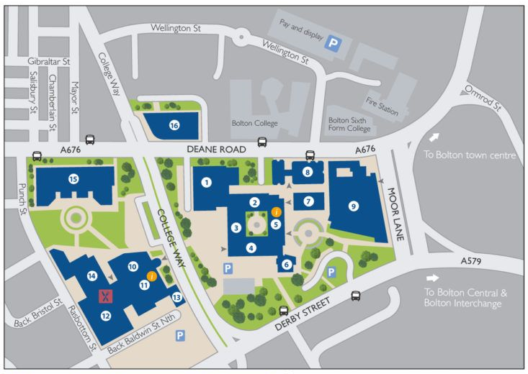
Upon your arrival, student ambassadors will meet you at our coach drop-off point. If your group are running late, please contact the event team using the details above.

Coach Drop-Off Point
Our coach drop-off point is located at:

Senate House,
College Close,
Bolton,
BL3 6HE
What Three Words: ///reason.lawn.tower

In the event that your transport provider does not drop off at this point, please call event leads using the information above or make your way to our main reception (point 5 on the campus map or What Three Words: ///notes.soccer.cool).

Minibus Parking
A limited amount of minibus parking is available on campus, this must be arranged in advance of your visit by emailing schoolsandcolleges@bolton.ac.uk
If arriving by minibus, please make your way to main reception (point 5 on the campus map or What Three Words: ///notes.soccer.cool) upon arrival.

Day 1: Monday, 15th June |  | Quiet Room:  F-018 (Deane Suite Breakout Room)
09:30-10:00 | Arrival, breakfast, etc. |  | D2-028
10:00-10:30 | Welcome, intro, icebreakers |  | “
10:30-11:15 | Intro to law careers |  | “
11:15-11:30 | Break
11:30-12:15 | Scavenger Hunt |  | Across campus
12:15-12:45 | Lunch |  | C1-002
12:45-13:45 | Mini Mock Trial |  | D2-028
13:45-14:00 | Break
14:00-14:45 | Law Quiz |  | D2-028
14:45-15:00 | Round up and close |  | D2-028
15:00 | Buses depart

Day 2: Tuesday, 16th June |  | Quiet Room:  F-018 (Deane Suite Breakout Room)
09:30-10:00 | Arrival, breakfast, etc |  | D2-028
10:00-10:45 | Escape Rooms |  | D1-036, D1-042,  D1-046
10:45-11:00 | Debrief, quick break |  | D2-028
11:00-11:15 | The Murder |  | Atrium?
11:15-12:15 | Crime Scene and Forensics |  | Atrium?
12:15-12:45 | Lunch |  | C1-02
12:45-13:30 | CSI/Cluedo
13:30-13:45 | Break
13:45-14:45 | Trial Prep |  | D2-028
14:45-15:00 | Round up and Close |  | D2-028
15:00 | Buses depart

Day 3: Wednesday, 17th June |  | Quiet Room:  F-018 (Deane Suite Breakout Room)
09:30-10:00 | Arrival, breakfast, etc. |  | D2-028
10:00-11:00 | Public Speaking and Confidence |  | D2-028
11:00-11:15 | Break |  | D2-028
11:15-12:15 | Trial Prep |  | D2-028
12:15-12:45 | Lunch |  | C1-002
12:45-13:15 | Final trial prep |  | D2-028
13:15-13:30 | Break |  | D2-028
13:30-14:45 | The Trial |  | D2-028
14:45-15:00 | Debrief, evaluations |  | D2-028
14:45-15:00 | Round up and Close |  | D2-028
15:00-16:00 | Graduation Prep |  | D2-028
15:00-16:00 | Parent/Carer reception |  | M1-22
16:00-17:00 | Graduation |  | M1-14
17:00-17:15 | Final photo opportunities, etc.
17:15 | Final buses depart

What are the Hazard(s) | Who might be harmed &  How? | Likelihood | Severity | Risk Level Before Controls | Current Control Measures | Risk Level With Controls | Additional Controls Needed to Reduce Risk to as low as reasonably practicable
 |  | H- High (3)  M-Medium (2)  L- Low (1) | M- Major (3)  S- Serious (2)  SL- Slight (1) | H- High (6-9)  M- Medium (3-4)  L Low (1-2) |  | H- High  M- Medium  L- Low
Suitability of rooms and facilities used | Staff/ Students/ Pupils/Student Ambassadors  Risk of personal injury or accident if inappropriate facilities used e.g., slips, trips and falls | Medium | Serious | Medium 4 | - All areas will be well-lit (inc. stairs)  - Areas used will be cleaned/tidied before events, a visual check conducted and any issues reported  - Trips/fall hazards to be removed or controlled e.g., trailing leads covered or removed and spills cleaned and warning signs used. | Low | - Good housekeeping will be promoted throughout the event.
Fire Safety | Staff/ Students/ Pupils/Student Ambassadors  Lack of familiarity with fire alarm and evacuation processes may lead to injury/harm in the result of a fire | Low | Major | Medium 3 | - Evacuation procedures posted around campus.  - Evacuation process and assembly points outlined in welcome  - If the alarm sounds, staff members and student ambassadors will lead the group to evacuation points.  - Teachers and Tutors must carry a register with them at all times in order to account for their groups quickly in the unlikely event of an evacuation. | Low | - Fire safety risk assessment to be reviewed in light of visitors with a disability to ensure evacuation plan in place
First Aid | Staff/ Students/ Pupils/Student Ambassadors  Injury sustained on site | Low | Major | Medium 3 | - First aiders on site will be contactable quickly throughout the day by calling internal 3666 (01204 903666 on mobiles).  - Event leads will be personally first aid trained wherever possible | Low

Safeguarding | Pupils Under 18 /Vulnerable adults  Risk to under 18s personal wellbeing | Low |  | Major | Medium 3 | - Event staff are DBS checked  - Staff and student ambassadors receive relevant briefing/training to support working with young people on campus  - All participating staff will avoid unsupervised access to pupils on a one-to-one basis e.g. inviting another staff member to be present or avoiding situations where pupils are on their own- including ensuring pupils are supervised by staff/ambassadors outside during any toilet breaks. |  | Low |  | - If teaching staff or parents make staff aware of any specific issues regarding young people, further risk considerations will be made
Allergies and Health Conditions | Staff/ Students/ Pupils/Student Ambassadors  Increased risk of accident and/or illness | High |  | Major | High 9 | - Event lead will liaise with school/college before the visit to collect any relevant allergies/health conditions for the visiting group  - Event lead will review visitor info and make further plans as needed.  - Event lead will share any relevant medical and allergy information with staff/ambassador team |  | Low |  | - Event lead will take further measures as needed to facilitate students’ participation in activities e.g. adapted menu options at lunchtimes etc.
Arrival & Departure/ Movement around site | Staff/ Students/ Pupils/Student Ambassadors  Visitor may become separated from group  Potential for road traffic accident | Medium |  | Major | High 6 | - Designated coach drop-off point will be shared prior to visit day.  - Student ambassadors and staff will facilitate movement around campus at all times.  - All groups will use pelican crossings facilities at all times when crossing roads.  - Visitors will be alerted to dangers of roads/car parks on site, and reminded to use crossings when moving around the campus during the welcome.  - Event leads will explain key meeting points and identify supporting staff in their welcome address. |  | Low
Accessibility & Mobility Issues | Vulnerable Student/Pupils(s)  Lack of inclusion/risk of personal injury/illness | Medium |  | Serious | Medium 4 | - Event leads will contact Schools/Colleges in advance of any visit to request information about any access needs. Schools/Colleges should make event leads aware of any additional needs their group might have as soon as possible to ensure the university is able to support their visit.  - Event leads are able to arrange for ease of access to rooms on campus |  | Low |  | - Event lead to create additional inclusion plan for students as needed to support their ability to engage with the day.  - Event lead to brief all supporting staff and ambassadors prior to the event to ensure they are aware of visitors’ access needs
Workshops & Sessions | Staff/ Students/ Pupils/Student Ambassadors  Risk of personal injury/accidents during sessions | Low |  | Slight | Low 1 | - Staff and student ambassadors will ensure any equipment used is used in correct manner and will supervise visitors throughout their session.  - Any additional risks for subject specific workshops will be shared and reviewed prior to event.  - Visitors will be instructed not to use equipment unless instructed to do so by university staff. Equipment that should not be touched will be identified by a red circle sticker or by event staff on the day as needed |  | Low |  | - Any additional risks for specific workshops will be reviewed and a separate risk assessment generated if necessary
The risk level associated with this task / area has been reduced to as low as reasonably practicable
Signature of Assessor |  |  |  |  |  |  | Date |  | 17/04/2026

PUBLIC LIABILITY
The University of Bolton is a member of U.M.Association Ltd and the following insurance covers are currently in place:

Employers Liability
Certificate No: 016458QBE0123A/023

Public & Products Liability
Certificate No: UM023/94

THE UNIVERSITY OF BOLTON H&S POLICY and MANUAL

SECTION 9 – SUPERVISION AND RISK MANAGEMENT OF CHILDREN WITHIN THE UNIVERSITY

Procedure to be adopted when children are brought on site as part of the Learning Environment or for specific supervised tours of a Department
All Department must ensure that in such cases before any child is brought onto the Campus, the Department must ensure that a sufficient Risk Assessment has been carried out in relation to the significant risks, together with written procedures for significantly reducing these risks to the lowest level possible.
The Head of Department must approve such procedures. Such procedures will include:
- Level of supervision
- Emergency procedures
- Suitability of teaching rooms, equipment, etc.

Procedures for bringing Children on site as part of a Supervised Tour
When such tours are to take place these should be pre-arranged with the Campus Services Manager for shared areas and with the appropriate Head of Department where visits are to be made. The Campus Services Manager and Head of Department should advise the Tour organiser on any areas out of bounds to the tour and any local rules to be observed, i.e. when visiting laboratories, etc. The Tour organiser will be responsible for ensuring the tour is conducted in such a manner as to observe such advice. The Tour organiser will also be responsible for making sure that the tour has:
- Sufficient supervision
- There are no specific risks to children with disabilities in the tour itinerary
- For the safe evacuation of the tour in the event of an emergency

Children in the Halls of Residence
The Residential Services Manager must ensure that, before accepting children as residents, a Risk Assessment has to be been carried out to identify any specific risks to children and that procedures are in place to ensure that such risks are reduced to the lowest level possible.
Such Assessments should take in account:
- The age of the children
- The number of children
- The number of adults supervising the children

Children at a specialist function
The person charged with the organisation of the specialist function must consult with the Campus Services Manager and the University’s Health and Safety Adviser to ensure that all areas to be used are free from a specific risk to children. The person must also advise the parents/supervisor of the children of the procedures to be adopted for the supervision of the children.

